1. Group Members:

Yue Zhao (701385258) , Kaijing Wang (701093350)

1. Tower Defense.
2. Modifications:
3. We call this game “Revolving Restaurant” because it simulates that type of restaurant by setting the “dishes of food” as “enemies” and “customers” as “towers”
4. The desk of the dishes (or the path of “enemies”) is a circle in the grid, shown as the circle in yellow in the following graph:

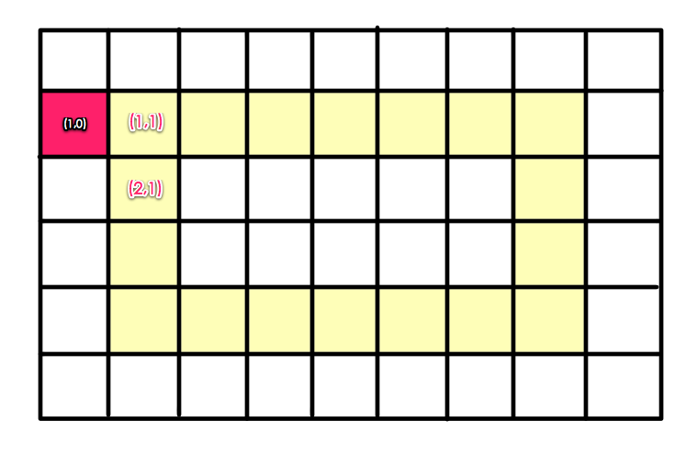

The red box (1,0) is where dishes are waiting to enter the desk at (1,1).

1. In fact the only different from traditional tower defense game is that the enemies do not reach any end point. If the customers (or the “towers”) fail to “eat up” the dishes, they will just keep circling on the desk.
2. The player wins the game when the customers eat up all the dishes given in a certain level.
3. The player loses if two plates crush when a new dish is being added onto the desk from the red box, that is, when (2,1) and (1,0) both are entering (1,1)
4. The heuristic score:

* Each customer has two integer properties: eating rate and appetite. The power score of a customer equals the eating rate multiplying the appetite. This represents how powerful a customer is when it comes to eating up the dishes.
* Each dish has an integer property: pieces. It represents the “health” of the “enemies” (food).
* So the heuristic score is the sum of total customers’ power minus total dishes’ health.